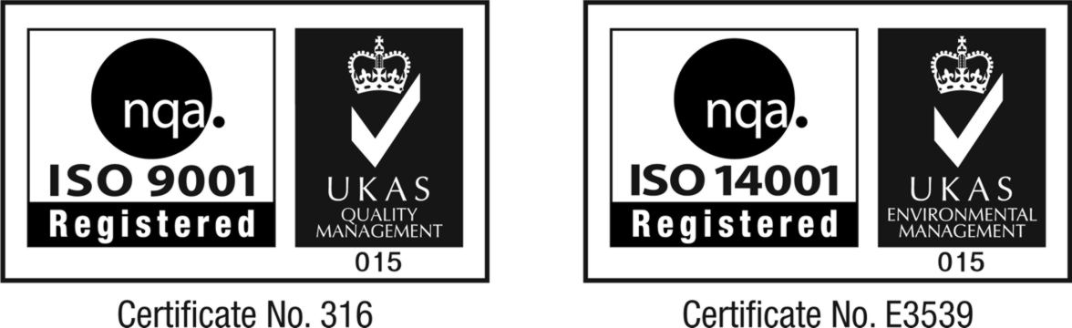
SAFETYDATA SHEET

From Cleenol Group Limited
Beaumont Road, Banbury, Oxon, OX16 1RB.
Tel : +44 (0)1295) 251721 Fax: +44 (0)1295 269561
Email: sales@cleenol.co.uk

Page 1 of 3

AUTOCLEEN DE-IONISED WATER

IDENTIFICATION OF THE SUBSTANCE / PREPARATION AND COMPANY

Product Name AUTOCLEEN DE-IONISED WATER
Part No and Pack Size 083214 (5L)
Safety Data Sheet No LD4
Supplier CLEENOL GROUP LIMITED
Neville House, Beaumont Road, Banbury, Oxon OX16 1RB
Main and Emergency Tel No. 01295 251721 (9.00 a.m. – 5.00 p.m. Mon - Fri)

Product Features
A purified source of water that is contaminant free

Directions for Use
This product is suitable for use in batteries, steam irons and any other equipment that requires the use of distilled water. Use as supplied. Avoid possible sources of contamination prior to the use of this product, i.e. soluble salts of inorganic and organic acids, cleaning solutions, etc. For battery top-up and other equipment, please follow carefully any manufacturer's instructions. Please note this is not suitable for drinking, or for oral hygiene.

2. COMPOSITION / INFORMATION ON INGREDIENTS

De-ionized water.

3. HAZARD IDENTIFICATION

NOT CLASSIFIED UNDER CHIP REGULATIONS

EYE CONTACT No hazard.
SKIN CONTACT No hazard.
INGESTION No hazard.
INHALATION No hazard.

4. FIRST AID MEASURES

EYES N/A
SKIN N/A
INGESTION N/A
INHALATION N/A

In all cases, if symptoms persist, seek medical advice and show this information sheet.

Note for Medical Practitioners : This information is registered with the National Poisons Information Service.

5. FIRE FIGHTING MEASURES

EXTINGUISHING MEDIA Non-flammable. Use extinguishing media appropriate for surrounding fire.
PROTECTIVE MEASURES IN FIRE N/A
HAZARDOUS DECOMPOSITION
PRODUCTS N/A

Page 2 of 3

AUTOCLEEN DE-IONISED WATER

6. ACCIDENTAL RELEASE MEASURES

PERSONAL PRECAUTIONS N/A
SPILL CLEAN UP METHODS Wash to drain.
PROTECTION OF ENVIRONMENT N/A

7. HANDLING AND STORAGE

USAGE PRECAUTIONS N/A
STORAGE PRECAUTIONS N/A

8. EXPOSURE CONTROLS / PERSONAL PROTECTION

VENTILATION N/A
RESPIRATORS N/A
PROTECTIVE GLOVES N/A
EYE PROTECTION N/A
OTHER PROTECTION N/A

9. PHYSICAL AND CHEMICAL PROPERTIES

APPEARANCE Colourless liquid
ODOUR None detectable
BOILING POINT 100⁰C
SPECIFIC GRAVITY 1.000 at 20ºC
FLASH POINT None
MELTING POINT N/A

10. STABILITY AND REACTIVITY

STABILITY Stable in normal use conditions.
MATERIALS TO AVOID N/A

11. TOXILOGICAL INFORMATION

TOXICOLOGICAL INFORMATION N/A
OTHER HEALTH EFFECTS N/A

12. ECOLOGICAL INFORMATION

ENVIRONMENTAL HAZARDS N/A

13. DISPOSAL CONSIDERATIONS

DISPOSAL METHODS Dispose of via reputable contractor and in accordance with local authority regulations.
Page 3 of 3

AUTOCLEEN DE-IONISED WATER

14. TRANSPORT INFORMATION

PROPER SHIPPING NAME N/A
UN No N/A
HAZARD CLASS N/A
ADR PACK GROUP N/A

15. REGULATORY INFORMATION

LABEL FOR SUPPLY N/A

SAFETY PHRASES N/A

STATUTORY INSTRUMENTS Chemicals (Hazard Information and Packaging) Regulations

16. OTHER INFORMATION

RISK PHRASES - FULL TEXT N/A

INFORMATION SOURCES Approved Supply List - HSC
Material Safety Data Sheet - Misc. manufacturers

REVISION COMMENTS Revised in accordance with Chemical (Hazard Information and Packaging) Regulations

REVISION DATE 1st September 2005

This product is only to be used for the purpose for which it was intended and in accordance with the specified instructions. This product should never be mixed with other chemical products and should be handled with care and stored carefully out of reach of children.

All Cleenol containers are recyclable and we would be pleased to provide relevant information about individual packs, and recycling agencies.

Information contained in this Safety Data Sheet is accurate to the best knowledge of Cleenol Group Ltd.

Reviewed by the Technical Director : 1st September 2005

Because of our continuing desire to incorporate technical improvements and innovations, and in view of the possibility of the
occasional need to substitute certain materials, Cleenol reserve the right to alter specifications without notice.

